Incline for our Solar Panels
Earths Relative to the Sun Movements

https://paroutsas.jmc.gr/project/seasons/08_ReasonForSeasons2.swf
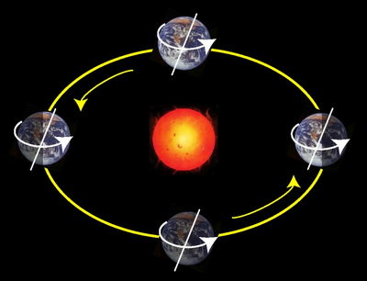

Students Points:
- Earth has seasons because our planet's axis of rotation is tilted at an angle of 23.5 degrees relative to our orbital plane.
- The seasons are not created due to the distance of the Earth from the Sun, otherwise it would be Summer all over the planet at the same time of the year.
- So what creates the Seasons?
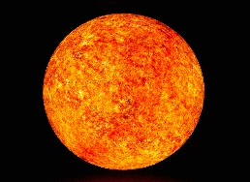


- We need to create a model based on what we know so far. 23.5 degrees is our planet axis and the orbit is Elliptical. Also the Summer is due to more intense Sun rays to Earth.
- For the model we need a sphere to represent Earth, an axis, a strong bulb and a rope.

